Groundsmans Association
Pitch Advisors March Blog

March Metrological Mayhem!
Volatile weather conditions are making ground decisions very difficult at the moment. We have had 19/20 °C spring/summer like temperatures as I blog, but I am hearing that there is another cold snap waiting in the wings. It may be worth just holding fire before you spring/summer fertilise with your NPK 12-0-9 + Fe & Mg on the square.

For the next couple of weeks a session with the sarel roller, after ‘topping-off’ the square at 10/12mm, would just open the surface to receive the fertiliser and to encourage and strengthen the lower root zone.

Please see the diagram below, based on Pythagoras’ Theorem, on how to set-up your square for the season.

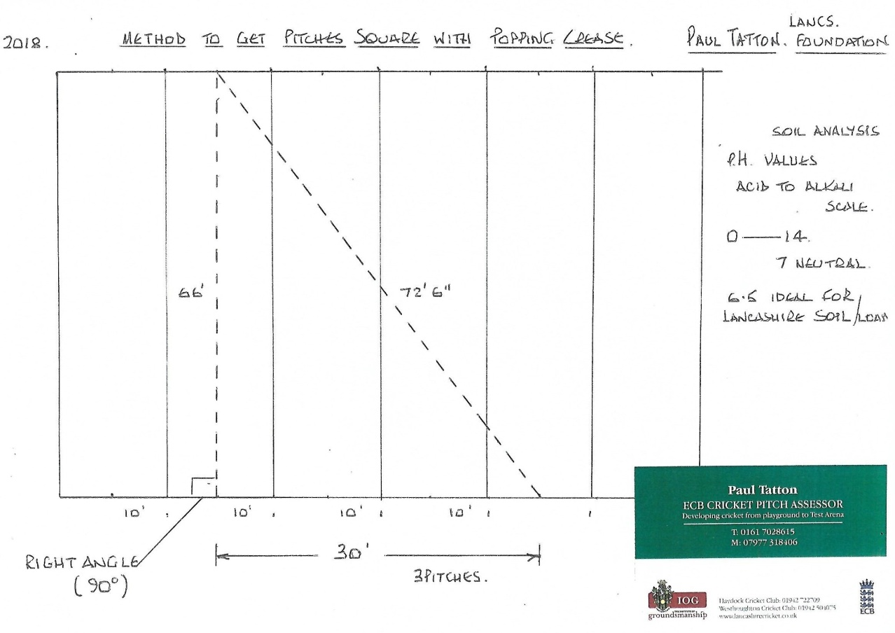

Pre Season Rolling: - Look to start your rolling programme this month if not already started. Only begin when the surface is dry, but when you press the surface with your thumb there is still some residual moisture on your skin. Start with a light roller and gradually build up the rolling weight. Use the ‘Union Jack’ system and roll in as many different directions as possible, always finishing in the direction of play.
Ground Machinery Servicing: - Make sure all your machinery is serviced and in good working order before the season starts.
Goods available: - A brand new Mk 3 Bowdry is available with £200 off the List price. First come first served. Contact Paul Tatton for more details.
Finally, this is an opportunity for me to thank all the messages of support I have received since my resignation at Haydock CC and my dismissal at Westhoughton CC hence my availability to continue doing what I thrive on.

