Groundsmans Association
Pitch Advisors April Blog

April Aspirations
It’s fill your boots time as we approach the start of the new season.

High on the agenda should be ‘Union Jack’ rolling of the square (across, diagonally and finally wicket to wicket) slowly increasing the weight each time.

Now is also a good time to put a spring/summer fertiliser (NPK 12.0.9 + Fe & Mg) on your square.

No apology for including the pitch square diagram again this month, which helps to square up the pitches using Pythagoras’ Theorem.

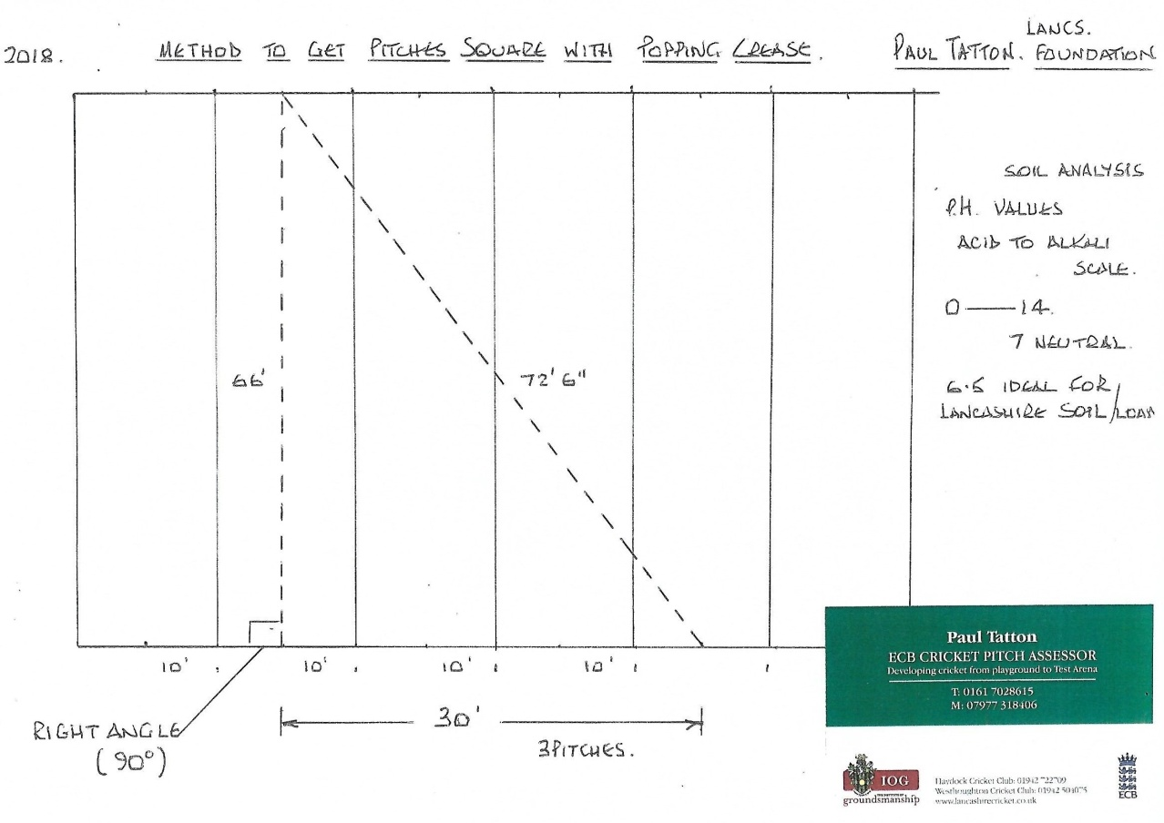

Pre Season Check List: -
- Sight screens
- Sawdust
- Boundary rope
- Fielding discs (ideally 46/48)
- Roll-on cover tops and flat sheets
- Fuel – diesel & unleaded
- Stumps & bails
- Stump gauge
- Bowling markers
- Seed and loam for repairs
- Straight edge and marking frame
- Engine oil & WD40
- 3” line marker & paint
- Tyres inflated to the correct pressure
Equipment for sale: - Brand new MK3 Bowdry available for £490 (£200 off list price). Contact Paul Tatton for more information.

