Parent Helpers Pack - All Stars Cricket
All Stars Cricket is the England and Wales Cricket Board’s entry level participation programme, aimed at providing children aged five to eight with a great first experience in cricket.

Programme features:

- For all boys and girls aged five to eight
- Delivered nationwide at over 2,000 centres
- Eight one-hour sessions, held over eight weeks
- Emphasis on fun and being active
- Safe and fully accredited
- Valuable time with your kids – mums and dads are encouraged to take part too
- Easy online registration
- Includes a bonus participation pack of cricket kit
- Focus on developing your child's movement skills
  - Batting – hitting a moving ball
  - Throwing – underarm and overarm
  - Catching – small and large balls
  - Bowling – overarm
  - Running – lots of movement
  - Teamwork – fun games with friends
  - Communication – the basics of cricket
  - Spirit of Cricket – how to respect others

Every child that registers will receive a participant backpack full of goodies (see below) sent straight to your door.

Over 67,000 children took part in All Stars Cricket sessions in 2019, with 2,212 centres hosting sessions. We’re looking forward to 2020, when hopefully even more kids can enjoy ‘Big Moments’ and become All Stars!

Your All Stars activator will oversee the programme at your Cricket club/centre
The All Stars Cricket activator is the key volunteer who will create a fun and inclusive environment for kids and parents alike. To become an activator you need to be enthusiastic, vibrant, motivated and an individual who inspires young children and creates a fantastic all-round experience.

Although many All Stars Cricket activators have experience of cricket it is by no means essential – first and foremost, we are looking for people with fantastic personal skills.

There are potential activators all around you: Teachers, teaching assistants, enthusiastic parents, junior cricket club captains or role models at your cricket club centres or within the local community.

Once you have decided to become an activator, you are provided with comprehensive face-to-face and online training and support to equip you with all the tools needed, including kit, to successfully implement the all stars fun and exciting programme.

For returning activators, it is not compulsory to attend training a second time – however a refresher session is recommended every 2 years, as the curriculum is updated based on the feedback of children, parents and fellow activators. The updated programme will be available on the icoachcricket app each April.

All activators are encouraged to join the All Stars Cricket activators Facebook group for additional support and the opportunity to speak to activators across the country. In terms of kit, they will be able to top up their existing activator clothing or select clothing options for others supporting their role.
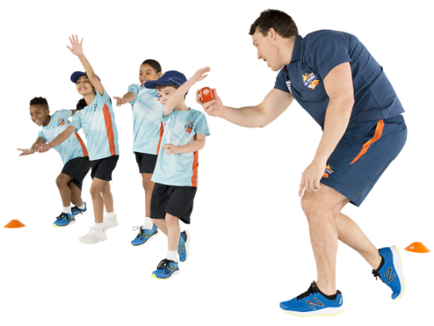

Parents, how can you help support All Stars Cricket at your club/centre
An important part of All Stars Cricket is that parents and siblings are encouraged to be involved too. It is a brilliant way for you to spend time as a family and with your child(ren) outdoors this summer.

All parents are asked during the registration process what activities they would be interested in helping out with during the programme. If you do indicate an interest, your centre will be in touch with further information and you’ll be given lots of support along the way.
There are many ways that you can help out during the programme, this includes:
- Becoming,
  - A fully trained lead activator
  - a fully trained support activator
  - a parent helper, supervising fun activities for some, or all sessions
  - your centre “meet and greet” person
  - your centre registration person
  - a valuable member of the centre refreshments team
- or purely enjoy some play time with your child(ren) taking part in the sessions

For an hour a week over an eight-week period, the fully trained (and vetted) activators and parent helpers will deliver game-based activities that teach basic cricket skills including catching, throwing and hitting moving balls and social skills such as teamwork and communication. Held at accredited cricket clubs, these courses are the perfect way for your child to learn about cricket and make friends in a safe and, most importantly, fun environment.

In your child's participant pack (year 1)
When you register your child for the first time for All Stars Cricket they will receive a bonus participant pack, including:

- Backpack
- Cricket bat
- Cricket ball
- Personalised shirt with name
- Cap
Every child that returns to All Stars Cricket (from year 2) will receive new kit to progress their development as an All Star, it includes:

- New backpack
- Cricket bat
- Cricket ball
- New star design personalised shirt
- Stumps
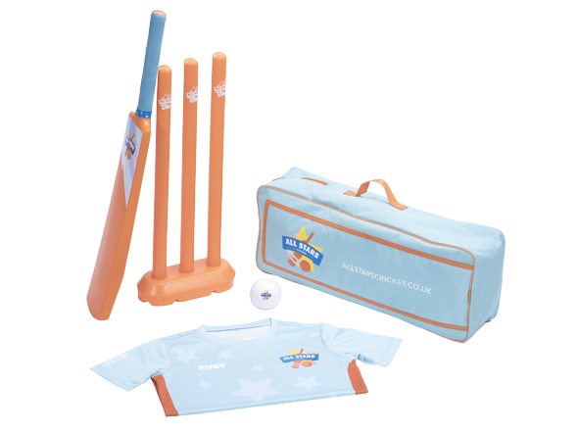

Why is All Stars Cricket good for my child?
All Stars Cricket will provide your child with all of the fundamental skills they need to play. Through lively, fun games, they will learn about cricket and be better prepared to take part in all sports. Over the eight-week programme, the trained activators will teach your child to:

- Catch and throw a ball
- Hit a moving ball
- Bowl with a straight arm
- Play a basic game of cricket
- Work and communicate as a team
- Have lots of fun with new friends

All Stars Cricket is also fantastic for parents. For an hour a week all mums and dads are invited to get involved and play cricket with their children. We know this is a great way to spend time with your child and create memories that will last a lifetime.

We at Lancashire Cricket believe that cricket is a great way to spend time as a family being active, which is why All Stars Cricket encourages each and every child and parent to continue learning and playing cricket at home. This can be in your garden, in the park, on the beach, anywhere – all you need is a bat and ball.

If you have never played cricket then check out our suggestions to try with your child.

Tips:
You don’t need to know the rules, make up your own
- If your child is a beginner, use a big ball so they enjoy hitting and catching the ball
- Cricket can be broken down into skills like catching practice
- Throw the ball under arm and slowly
- Use our garden games videos as a guide or create your own variations
- Remember to have fun!

All Stars Cricket - Frequently Asked Questions

How can I get involved as a parent?
An important part of All Stars Cricket is that you will be encouraged to be involved too. It is a brilliant way for you to spend time with your child outdoors in the summer. All parents are asked during the registration process if they would be interested in helping out during the programme. If you say yes, your centre will be in touch with further information and you’ll be given lots of support along the way.
How much does the programme cost?
The minimum retail price of All Stars Cricket is £40, although some centres across England and Wales may charge more where additional services are provided eg, food, drinks, club membership etc etc.
What does each child receive as part of the programme?
The programme cost includes eight 45-60 minute All Stars Cricket sessions and your child’s personalised participant pack.
How old does my child have to be to register?
All Stars Cricket is aimed at 5-8 year olds. If your child is younger than 5, we still welcome them to be involved but ask that a parent or guardian gets involved as a parent helper and supports their involvement in the programme.
When will my child’s kit be delivered?
Kit will take around 10 working days to be delivered, although could take a little longer if registration is close to the official All Stars start date.
What can my child and I expect at an All Stars Cricket session?
All Stars Cricket is an action-packed, fun programme of game-based activities that will help develop the fundamental movement skills your child needs for an active life. Throughout the eight weeks, your little All Star will be learning lots of new skills, making friends and most importantly having an exciting summer!
Is the programme safe?
Yes, the All Stars Cricket programme is an initiative designed by the England and Wales Cricket Board (ECB). The ECB requires all of the centres to undergo safeguarding, risk and insurance assessments before they are accredited. Alongside this, all of our All Stars Cricket activators have received training and are fully checked through the Disclosure and Barring Service (DBS).

