Vitality Girls U13 & U15 Club T20 Competition 2024
Entry Form
I confirm that the below named Cricket Club wishes to enter the Vitality Girls U13 / U15 Club T20 Competition 2024. In submitting this entry form we acknowledge that, if accepted, we agree to abide fully by the rules of the competition and the dates issued by the England & Wales Cricket Board (ECB) together with any additions or amendments made by the ECB Domestic Cricket Operations Team. I also confirm that our club has an active site on Play-Cricket and agree to upload the results of the matches onto the website and email them through to competitions@ecb.co.uk within 24 hours of the match being completed.
Club information
Club name
Ground Address & Postcode
County Cricket Board (primary affiliation)
We wish to enter the following (please tick as appropriate):
Girls U13 Club T20 Competition
Girls U15 Club T20 Competition
Contact Information
In supplying this contact information I fully understand that these contact details will be circulated to other clubs entering this competition and give my full authority for this information to be used in this manner.
Name of Club Contact
Position at Club
Address & Postcode
Email
Telephone (mobile preferable)
Alternative Contact Person & Email
via email to either sue.laister@ecb.co.uk or competitions@ecb.co.uk

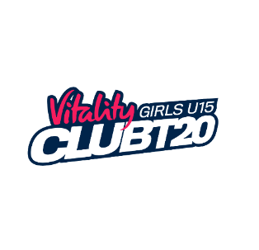
All entry forms must be completed and returned by Friday 9th February 2024

